Engineering Report: Smart Rodent Trap

Team members: Rebecca Janes, Alexandra Piñeiro, Roshan Venkatesan, Louie Lu, Talbot Taylor

1. **Executive Summary**

The client desires a solution that can detain, detect, and release mice safely without inflicting harm. There are mice to be caught, but existing humane methods to catch and release mice are ineffective as they do not effectively communicate with the user or minimize contact with mice for sanitary purposes.

This report provides documentation of the project’s design and development process, as well as context to the process, conveying the significance of the solution’s final prototype state.

We arrived at our final design after considering multiple alternatives as a team, consulting more experienced individuals in the field of engineering, and continually refining the prototype throughout the manufacturing process.

The project was a success and we developed a prototype that met the needs of the client. With more time, we can further refine the prototype to make it more reliable, durable, and improve overall quality. Our design is compact, cheap, easy to use, and can be manufactured on a large scale.

1. **Introduction and Problem Statement**

There is enough space on earth for all creatures to live peacefully! The goal of this project is to design and prototype a smart humane rodent trap for indoor and outdoor use that can capture any type of rodent around residential or commercial properties. The device should send an alert to a mobile device or house station to notify the location at which the rodent was trapped. The device must be battery operated with a battery lifetime of a least one month. The compact and portable trap must allow easy release of the captured rodent to a safe place in nature without contact between the user and the rodent after enjoying its treat! The rodent trap must be cleanable and reusable for 100 times.

***Table 1.*** *Objectives of the project and metrics used to evaluate success.*

|  |  |
| --- | --- |
| **Objective** | **Metric** |
| Resistant to weather conditions | Must be able to function in 5˚C - 40˚C temperature conditions |
| Small | Largest dimension no longer than 50cm |
| Light | No heavier than 5 kg |
| Detect when rodent enters | When rodent in 10cm inside trap, door closes within 2 seconds |
| Must be able to independently control different traps | Door must open (to release) from a phone or button |
| Batteries must be replaced externally | Uses disposable batteries |
| Batteries must last for at least a month | Should be able to power trap for 35 trapping events |
| Notify human or trapped rodent | Human receives notification on their phone via email or text |
| Remote release of rodent | Can be released from 10m away via bluetooth |

1. **Design Alternatives Considered**

***Table 2.*** *The different functions required and possible means for executing each function.*

|  |  |
| --- | --- |
| **Function** | **Means** |
| Trapping rodent | Trap door (spring loaded), garage door, diving board, falling cage, net |
| Enclose rodent | Cylinder, rectangular pyramid |
| Release rodent | Gravity, motor, crank, loud noise |
| Sustain rodent | Nutrients, heat lamp and fan |
| Alert user of trapped rodent | Bluetooth, phone application, cellular, email, alarm, SMS |
| Remote control release | Bluetooth, phone application, cellular, email, alarm, wire, timer button |
| Stop door from reopening | Lock, gravity, food, warmth, fully enclosed mesh, spring |
| Sense rodent | IR sensor, weight sensor, strain gauge, |

In the earlier stages of designing the trap, we were planning on using a spring-loaded trap door and a bucket. The rodent would walk up a plank, and we would install infrared sensors or motion sensors to sense when the rodent would get on the plank. We then realized that it would not be practical, since it would be harder to keep the rodent safe from weather conditions, and it wouldn’t be as easily portable, we then started to develop the idea of a garage door, a motor, a crank, and a fully enclosed mesh trap. However, we made some calculations and realized that, for a rodent trap, it would take too much power, and thus raise the price unnecessarily. Finally, we arrived at the idea of having an acrylic cage, and a trap that would depend mostly on mechanical triggers, which will be explained in further detail later in the report.

1. **Basis for Design Selection**

***Table 3****. Means chosen for each of the project functions*

|  |  |
| --- | --- |
| **Function** | **Means** |
| Trapping rodent | Trap door (spring loaded) |
| Enclose rodent | Rectangular prism |
| Release rodent | Electromagnet controlled door |
| Alert user of trapped rodent | SMS |
| Remote control release | Timer button controlling electromagnet opposing gravity until release |
| Stop door from reopening | Door 1: spring and stopper  Door 2: mechanical lock |
| Sense rodent | Mechanical weight sensor |

* A trap door was chosen due to its simplicity, ease of construction, and effectiveness. A garage door would require many components for the door and risks jamming, a diving board is not compatible with our rectangular prism design of the trap, and a net would not be fast enough to trap the rodent.
* A rectangular prism allowed for easy construction and its compact shape means the trap can be placed in tight areas. A cylinder would require flexible material which could sacrifice strength and would be required to stand up vertically which makes it take up more space. A rectangular pyramid would also take up more space vertically and is a needlessly more complex shape.
* An electromagnet is a reliable and compact device that can help release the rodent with minimal power consumption due to our circuit. We combined it with gravity to further make it more energy efficient. A crank would require more power and may not have the required strength to pull up the door to rearm it assuming it is compact.
* We chose the SMS due to its speed, reliability, and the fact that most people carry a phone at all times which makes the notification more reliable. The user may not always have their email account open which makes email less optimal, Bluetooth does not cover a wide range, and developing a separate application is an unnecessary complication as opposed to an SMS.
* Using a timer button with the electromagnet and gravity greatly simplifies our design and minimizes any risk of the trap not opening. A wire takes up space and is not optimal, developing an application or remote release would consume much more time to implement and may not always work due to its remote nature and is affected by distance.
* We used a mechanical lock and spring due to their strength and stability. There is minimal risk of the rodent escaping since it would require a large amount of force to overcome the lock or spring.
* A mechanical weight sensor eliminates the need for any programming or circuitry and can be used indefinitely since it requires no power.
* We eventually settled on a 9V battery to serve as a power supply to the circuit of the trapping system this was an inexpensive and simple option that the user could replace when the battery was empty. This would take quite a few uses as seen in our calculations in Appendix A.

1. **Evaluation of Results**

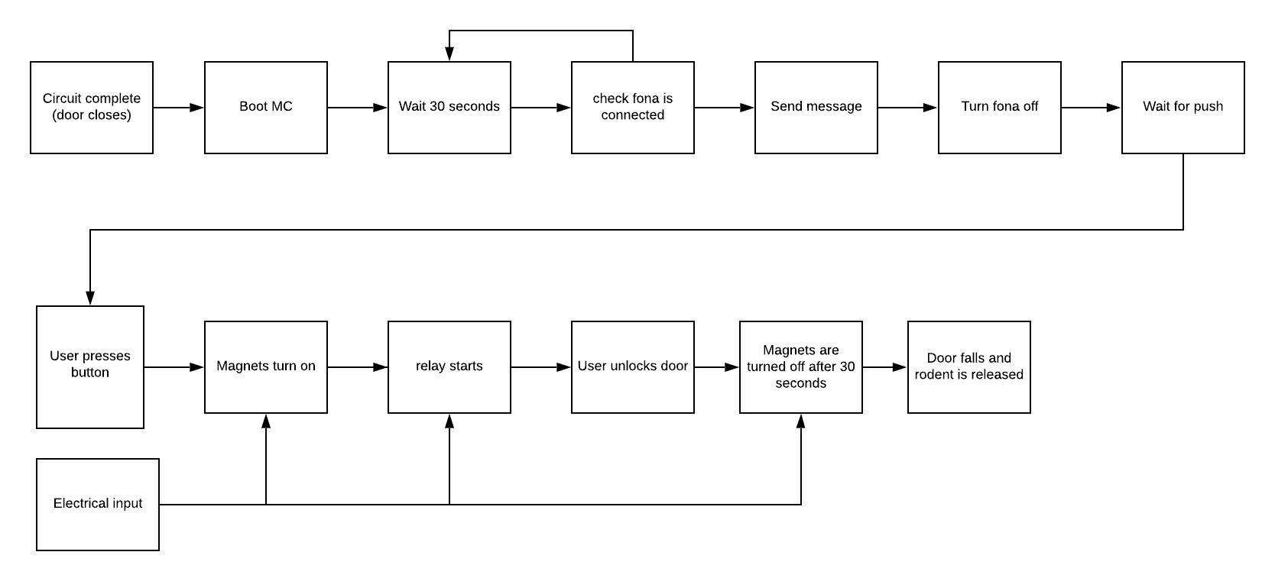

***Figure 1.*** *Glass box analysis showing the processes that occur during each use of the trap*

In the end, our group ended up meeting every objective we had. We chose the exterior of the trap to be made up of acrylic, so that it would be resistant to weather conditions and sturdy enough to hold the rodent in place. It is small (18.2x5x4.8in), and light(less than 5kg).Its battery can also be replaced externally, as it is placed in a battery holder on the roof of it.

The trap also detected when the rodent entered. Once the rodent spotted the bait, it would walk in the trap and onto the mechanical weight sensor. This mechanical weight sensor would trigger the door closing because of the torsion spring placed at the center of the door. Once the door closed, it would lift up and touch the switch, which completed the circuit. This would then boot the MC, and then wait 30 seconds, then check that the fona is connected. If it is, the arduino sends an SMS to the user with the text “You caught a rodent at rodent trap A!!”, which was one of our main objectives when designing the trap. If it isn’t, it waits 30 seconds again, and repeats the process until the fona is connected.

After the message is sent, the message is turned off. Now, the rodent is trapped safely in its box, with enough food to last a couple of days as it waits for the user to let it out. Once the user presses the button (user is able to independently control the trap) to release the rodent, the magnets are turned on, which causes the relay to start. The user can now unlock the door. He/she now has about 30 seconds to get away before the door falls and the rodent is released. Although it isn’t precisely what one would call a “remote release,” it achieves the same goals as if the rodent were released remotely. As long as the trap works smoothly, the batteries should have enough power to last 60 uses, which is much more than our original goal of enough battery power to last a month.

There were definitely some limitations we faced in the design and assembly process. For example, in the future, it would be best to purchase a torsion spring. We spent a long time trying to find one that was just right (we even had to order one from overseas) and ended up manually twisting the 180 degree deflection angle to a 90 degree deflection angle. After testing the trap various times, the spring began to lose its strength, which is why we had to attach velcro to both the door and the switch, because it was not strong enough to go up with the force needed to trigger the switch. It would also be best if we added a handle at the top of the trap somewhere, so that it could be more mobile, and the user could free the rodent safely.

Bill of Materials

|  |  |  |  |  |
| --- | --- | --- | --- | --- |
| **Part name** | **Quantity** | **Function** | **Dimensions** | **Cost** |
| Electromagnet | 1 | To keep the trapdoor shut when activated. | 1.25”tall 0.75” diameter 9lb pull force | $44 |
| Fona Arduino | 1 | To send a text to the user and regulate how long the electromagnet is active. Also provides power. | N/A | $40 |
| Relay | 1 | To close the circuit when the button is pressed. | 5V | $5 |
| Torsion Spring | 1 | To close the door when the rodent steps on the plate | Diameter: 0.29 in  Length: 2 in | Custom-made  $20 |

|  |  |  |  |  |
| --- | --- | --- | --- | --- |
| **Part name** | **Quantity** | **Function** | **Dimensions** | **Cost** |
| Breadboard | 1 | Connects all the electrical components together | 400 point breadboard | $6 |
| Battery | 1 | Supplies power | 9V | $6 |
| Push Button | 1 | Activates the electromagnet | 12mm^2 | $0.5 |
| Washer | 1 | Locks the door when attracted to electromagnet |  | ~$0.1 |

|  |  |  |  |  |
| --- | --- | --- | --- | --- |
| **Part name** | **Quantity** | **Function** | **Dimensions** | **Cost** |
| Acrylic Sheets | 2 | Trap encasing | 12”x24” | $13x2 |
| Joints | 6 | Hold the trap together | 1.5 x 1.5 in | ~$3 |
| Screws | 12 | Hold the trap together |  | ~$1 |
| Battery Case | 1 | Holds the battery | 9V Battery Size | ~$0.5 |
| Plastic Box | 1 | Encloses the circuits | 7.8”x4.7” | ~$5 |
| Switch | 1 | Is pressed when door is closed, sends SMS |  | $0.5 |

**Total Cost:** ~$158 (well under budget)

1. Supporting Material

***Appendix A.*** *Spring Force Calculations*

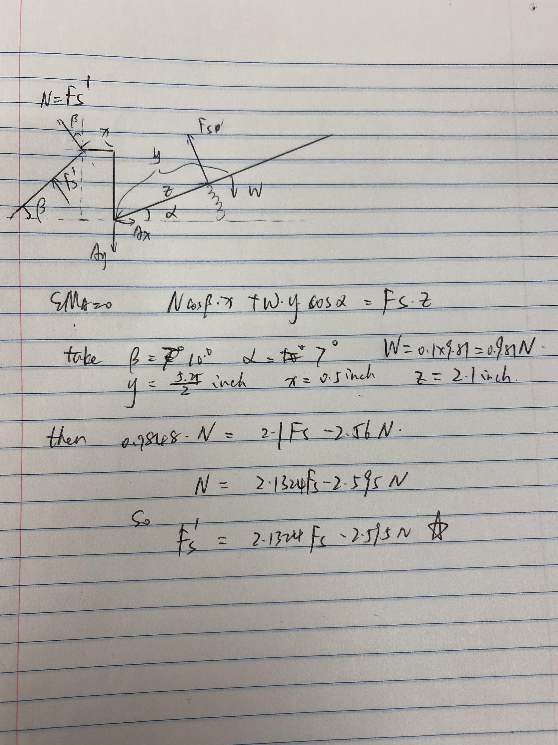

***Appendix B.*** *Circuit Diagram (with pictures)*

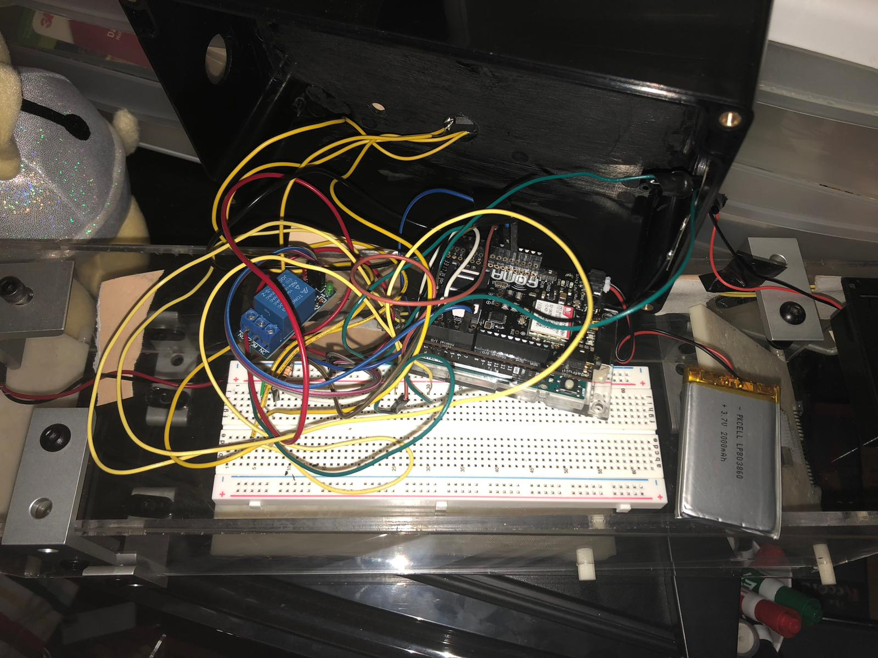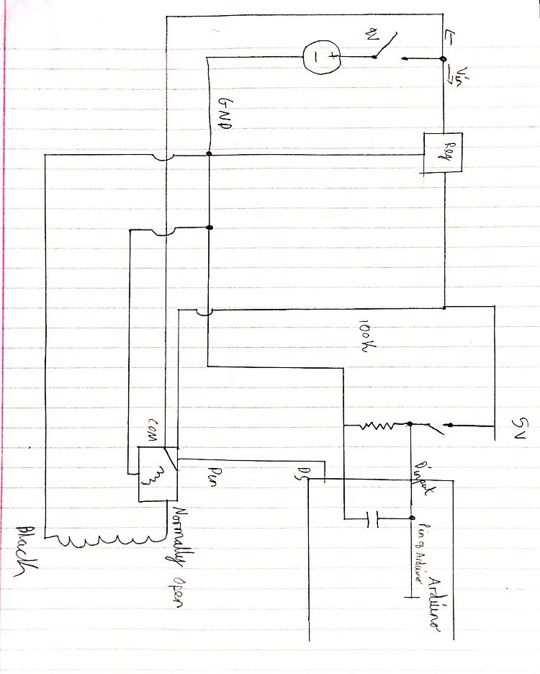

***Appendix C.1*** *Arduino/Fona code for sending text message*

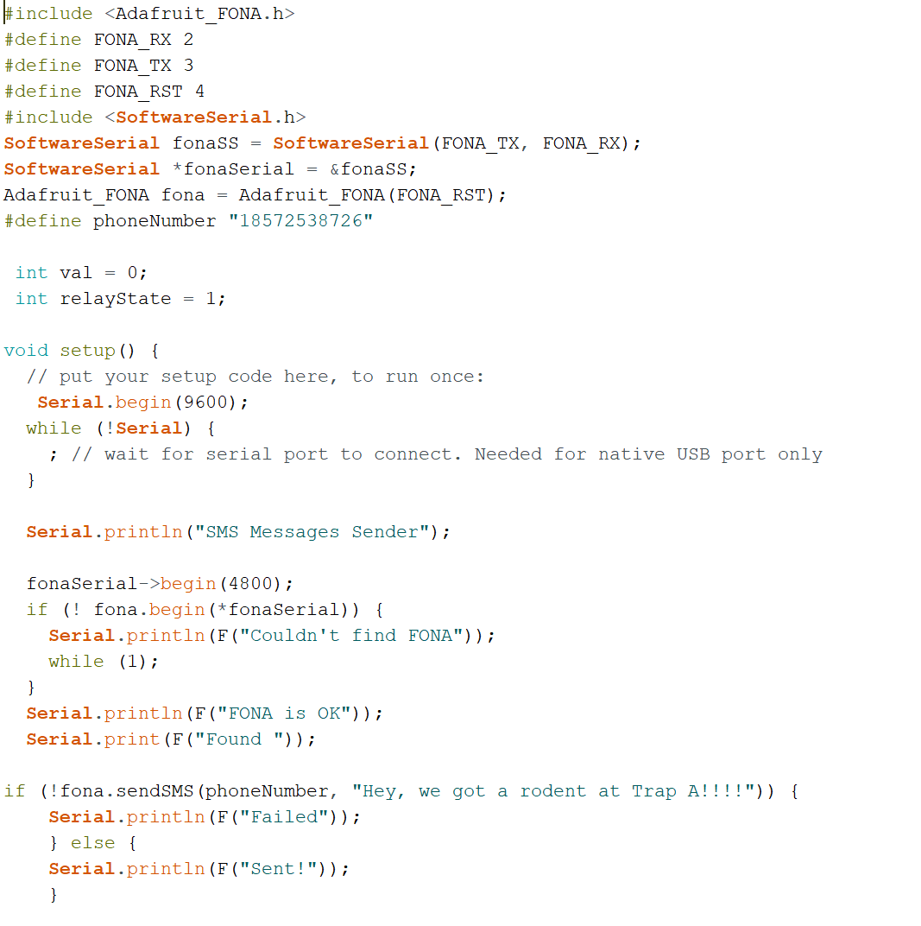

***Appendix C.2*** *Code for magnetic remote release*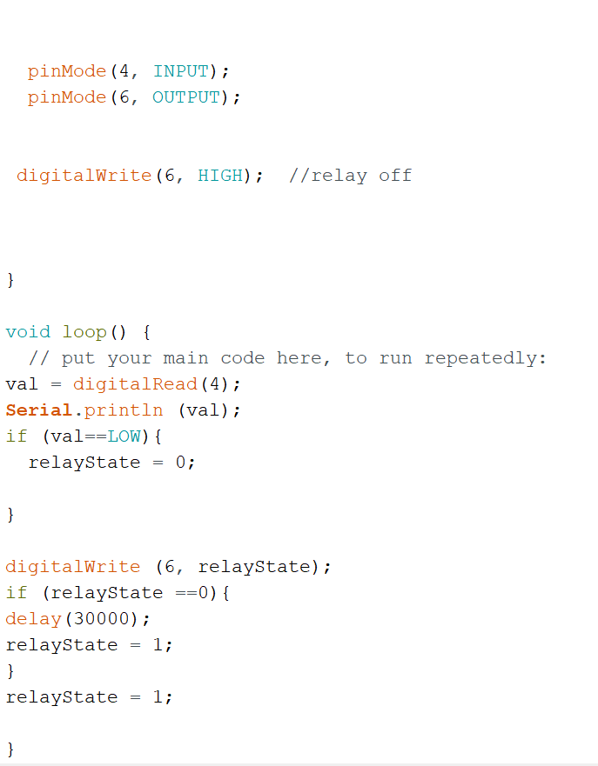

***Appendix D.*** *Battery Life Calculations*

9V battery contains 600mA hours

Fona 800 Board to send a text message: Uses 200mA run for 1 minute

Electromagnet to keep backdoor closed: Uses 1000mA run for 30 seconds

With normal usage the battery should last for over 60 catches

***Appendix E.*** *Miniature model photos*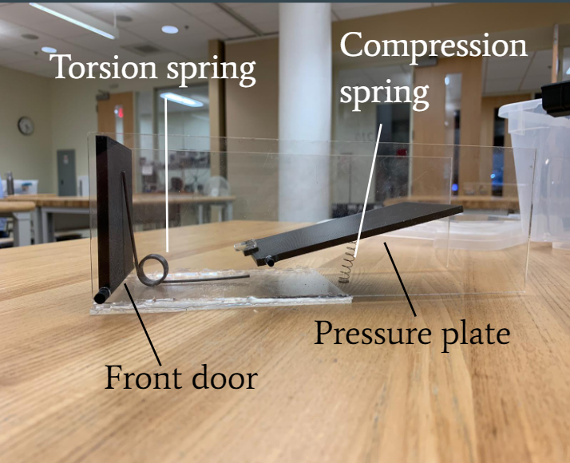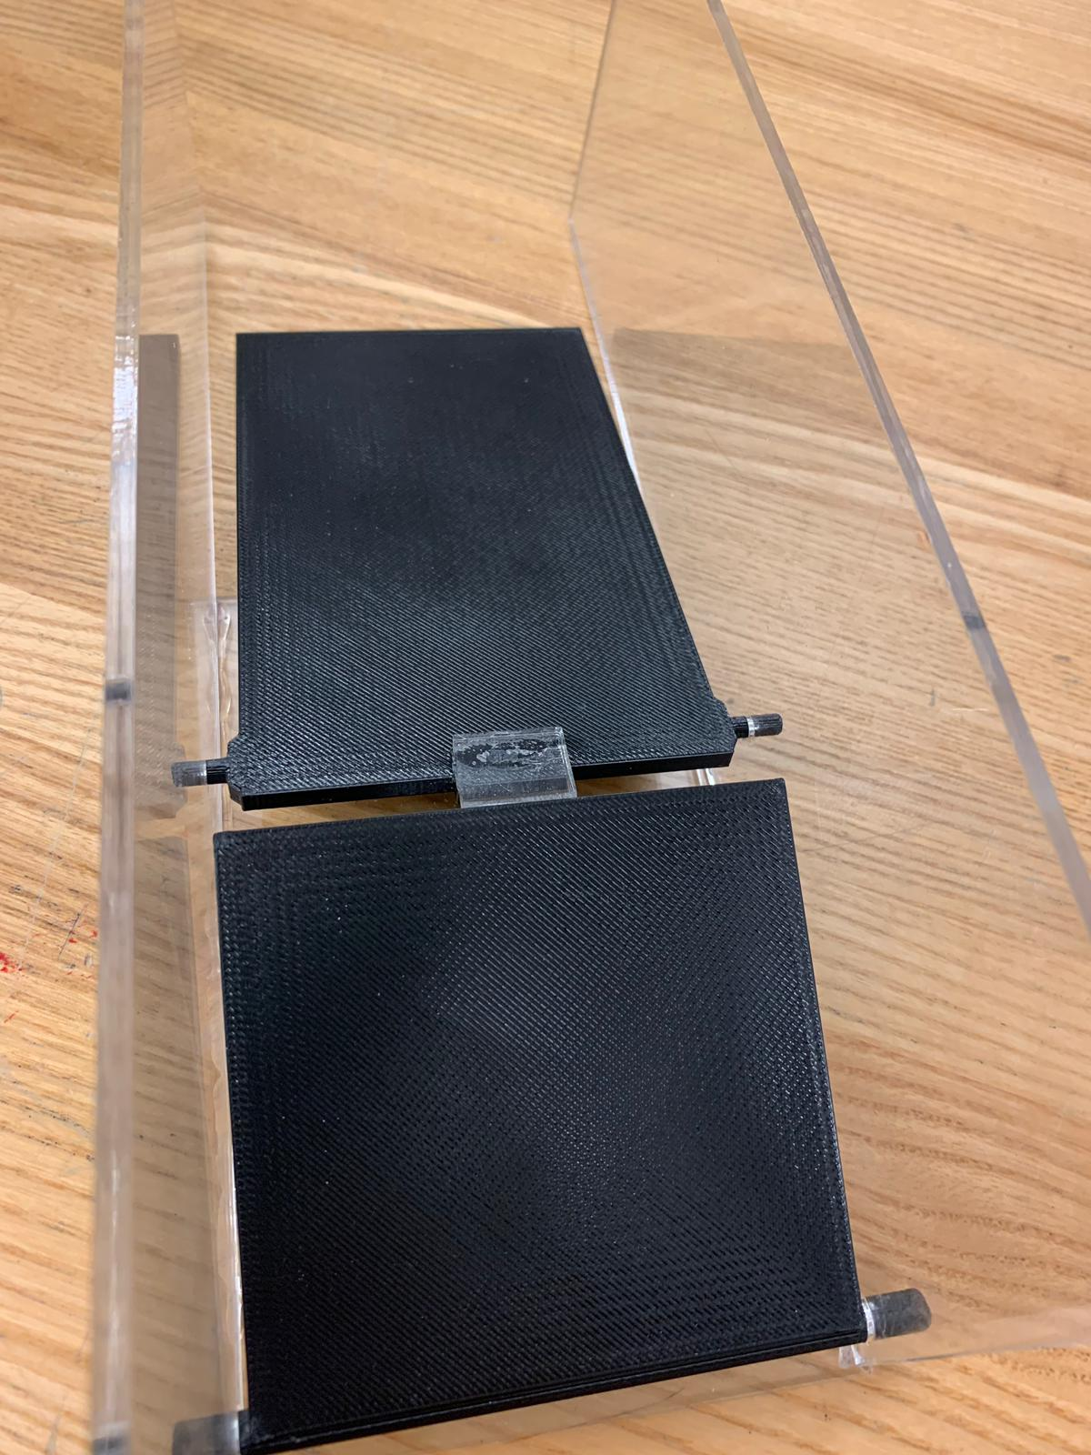

***Appendix F.*** *Prototype sketches*

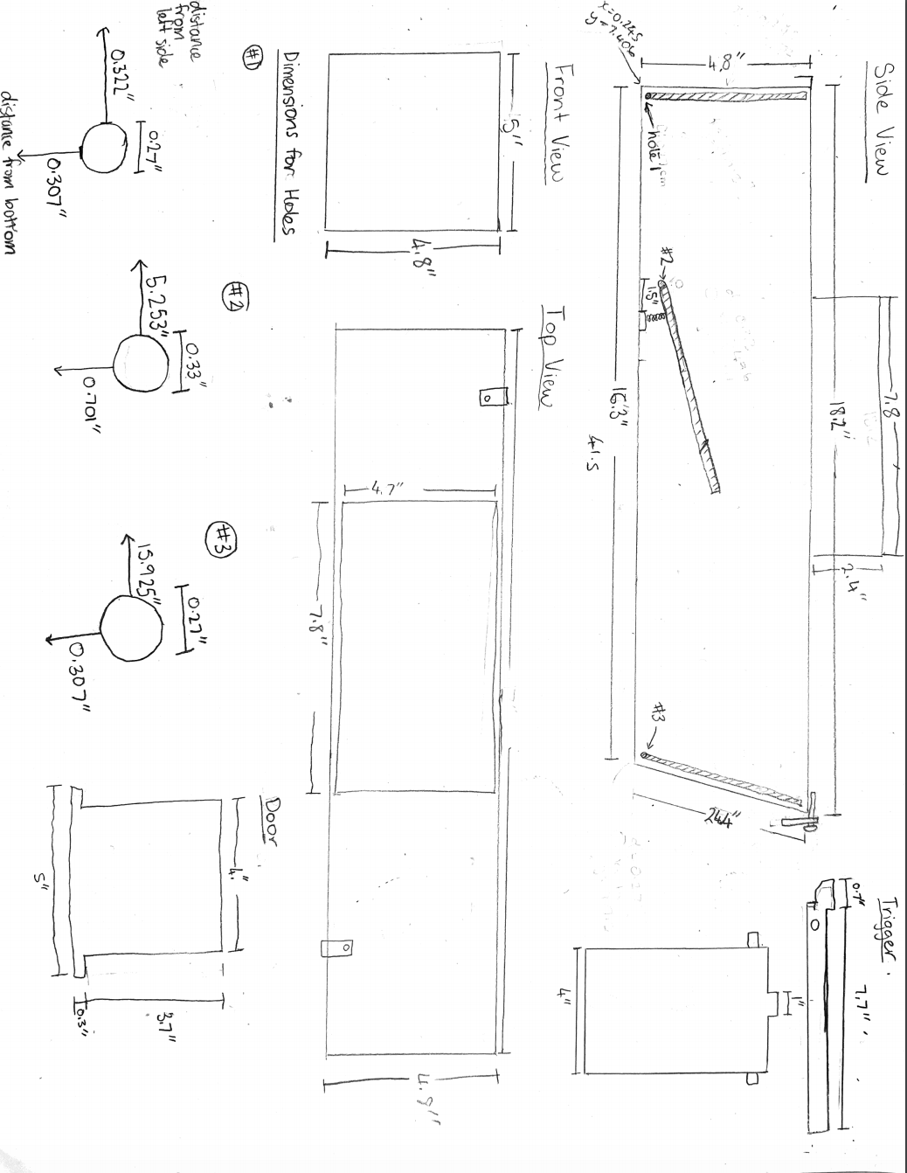



***Appendix G.*** *Final Design Pictures*

